3.8 Maxima and Minima of Functions of Two Variables

Definition:
- A function of two variables has a local maximum at if when is near . The number is called a local maximum value or simply a local maximum.

- A function of two variables has a local minimum at if when is near . The number is called a local minimum value or simply a local minimum.

Note: We can make the notion of “near” precise by saying: “there exists some such that for every in the disk centered at of radius , .”

Note: Local maxes/mins are z values!

Remark: If we replace the words “when is near ” in the above definitions with “for all ” then we obtain the definition of absolute maximum and absolute minimum respectively, and we say has an absolute maximum at and has an absolute minimum at .

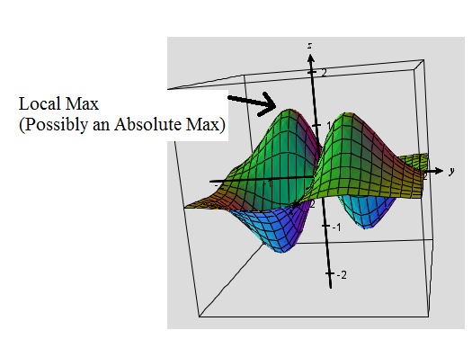
Ex: In the picture below a local max is identified. We cannot determine if it is a global max because it could be exceeded in a part of the graph that we cannot see.

Theorem: If a function of two variables has a local maximum or minimum at and the first-order partial derivatives of exist there, then and .

Proof: The proof is fairly straightforward; however, it is not included in the textbook.

Definition: A point is called a critical point of if and or if one of these partial derivatives does not exist.

Note: Critical points are where local minima/maxima MAY occur.

Example 1: Find all the critical points of the function .

Theorem (Second Derivatives Test):
Suppose the second partial derivatives of f are continuous on a disk with center , and suppose that and . Let . Then,
- If and , then is a local minimum.
- If and , then is a local maximum.
- If , then is not a local maximum or local minimum. We say that is a saddle point of .
- If , the test is inconclusive (i.e. it gives no information).

Proof: The proof is beyond the scope of this course. The key to proving this result is generalizing the notion of the second derivative test from calculus one.

Note: Results 1 and 2 are fairly easy to remember if one recalls the second derivative test from calculus 1.

Example 2: Find the local minimum and maximum value(s) and any saddle points of the function .

Note: Language in the above example is very important. In particular, it is proper to say that there is a saddle point at (0,0). It is also proper to say that there is a local minimum of -1 at (1,1), or there is a local minimum of -1at (-1,-1). It would NOT be correct to say that there is a local minimum of (1,1).

Example 3: Consider the function . Show that (0,0) is a critical point of f . Then, show that the second derivatives test is inconclusive in classifying (0,0).

We now move to discussing absolute extrema.

Definition (intuitive): A closed set in is one that contains all of its boundary points.

Note: For now, we will think of “boundary” in the intuitive sense. It is possible however, to give a mathematically rigorous definition of boundary point.

Ex: Based upon the above definition is a closed set, and is not a closed set.
Not
Closed
Closed

Definition: A bounded set in is one that is contained within some disk.

Theorem (Extreme Value Theorem for Functions of Two Variables):
If is continuous on a closed, bounded set D in , then attains an absolute maximum value and an absolute minimum value at some points and in D.

Proof: Beyond the scope of this course. This theorem is often proven in Real Analysis or General Topology.

Steps for Finding the Absolute Max or Min on a Closed Bounded Set:
- Confirm that is continuous.
- Find the values of at the critical points of in D.
- Find the extreme values of on the boundary of D.
- The largest of these values is the absolute maximum of on D. The smallest of these values is the absolute minimum of on D.

Example 4: Find the absolute maximum and minimum values of the function on the rectangle . Also, state where the absolute maximum and minimum values occur.

